Deep packet inspection project

Some basics concept:
• IP Address: The unique network identifier for a specific device, acting like the physical street address of an apartment building.
• Port: The identifier for a specific software application running on that device, acting like the apartment number inside that building.
• Packets: Small, manageable chunks of data containing routing instructions (header), actual data (payload), and error checks (trailer) that travel independently across a network.
• Packet Switching: The modern method of breaking data into packets and sending them via various shared network routes, rather than relying on a single dedicated line.
• Dynamic Routing: The automated process where routers act as traffic cops, constantly calculating the fastest paths for packets and instantly redirecting them around network outages or congestion.
• Circuit Switching: An older networking method (like classic landline phones) that requires opening and maintaining a single, unbroken physical connection between two points for the entire duration of the communication.

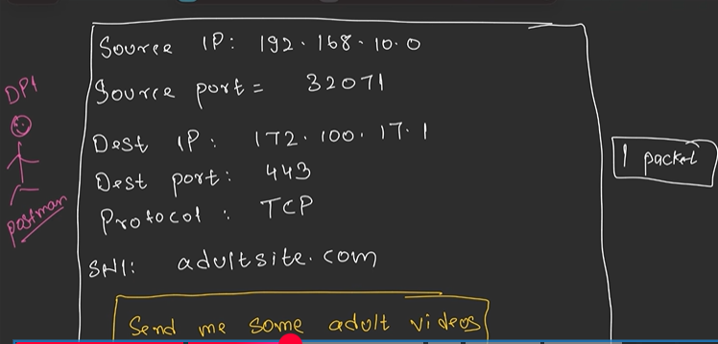

One packet which we are sending contains above information, and if there is alrge thing so we breakdown that thing into multiple packets, and our source and destination makes a connection and all packets are then send, means all above 5 things listed in pic are same for all packets once connection is made, niche bhi pic h

In the early days of the internet, one IP address usually hosted exactly one website. If your packet went to 10.0.0.1, the server knew you wanted Website A.
Today, because of things like Load Balancers and Cloud Hosting, a single IP address might host 1,000 different websites (e.g., cats.com and dogs.com live on the exact same server).
When you want to connect securely via HTTPS, your computer and the server must do a TLS Handshake before any actual data is sent.
- Your computer says "Hello."
- The server must reply by sending its SSL Certificate (its digital ID card) to prove it is the real website.
Here is the Catch-22 without SNI: Your computer encrypts the HTTP request (which contains the name cats.com). The server cannot decrypt this request until the secure connection is established. But the server doesn't know which secure connection to establish (should it send the certificate for cats.com or dogs.com?) because it doesn't know which website you want yet!

The Solution: SNI (The Name Tag)
SNI (Server Name Indication) is an extension added to the very first packet your computer sends during that handshake (called the ClientHello packet).
It simply adds the name of the website you want (e.g., cats.com) in plain, unencrypted text right on the outside of the secure envelope.

. The TLS Handshake (In Simple Terms)
A TLS Handshake is the process where your computer and a web server securely introduce themselves and agree on how to encrypt their conversation.
- The Analogy: Imagine meeting a spy in a park. First, you check their official badge to make sure they aren't an impostor (Checking the Certificate). Then, you both agree on a secret decoder ring to use for the rest of your conversation (Exchanging Encryption Keys). Once the handshake is done, you can safely pass secret notes.

2. TCP Handshake vs. TLS Handshake
These two handshakes happen one right after the other, but they have completely different jobs.
- TCP Handshake (The Connection): This happens first. It is strictly about establishing a reliable connection over the network. It uses a 3-way process (SYN, SYN-ACK, ACK).
  - Analogy: Dialing a phone number and asking, "Hello, can you hear me?" and they reply, "Yes, I hear you, can you hear me?" and you reply, "Yes."
- TLS Handshake (The Security): This happens immediately after the TCP connection is established. It is strictly about securing that connection so nobody can eavesdrop.
  - Analogy: Now that the phone call is connected, you ask, "Are you actually the bank? Show me your ID. Great, now let's switch to our secret language before we discuss my bank account."

3. What is SSL?
SSL (Secure Sockets Layer) is simply the older, deprecated predecessor to TLS (Transport Layer Security).
It was invented in the 1990s to encrypt web traffic. Over time, engineers found security flaws in SSL, so they built a newer, stronger version and renamed it TLS.
Today, SSL is essentially dead. The entire internet uses TLS. However, because the tech industry is stubborn with terminology, everyone still calls them "SSL Certificates" out of habit, even though you are technically doing a TLS handshake.

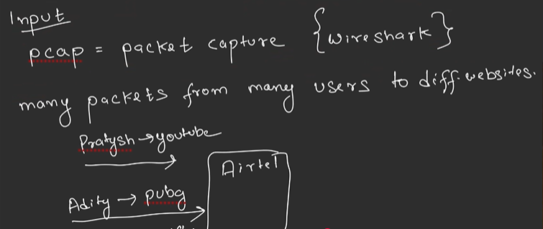

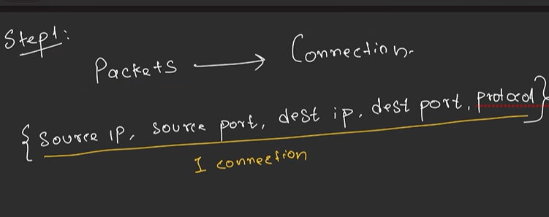

Once connection is made, only data changes for each packet but all 5 things are same, cuz large file is divided into multiple packets chunks and then send one by one once connection is made.

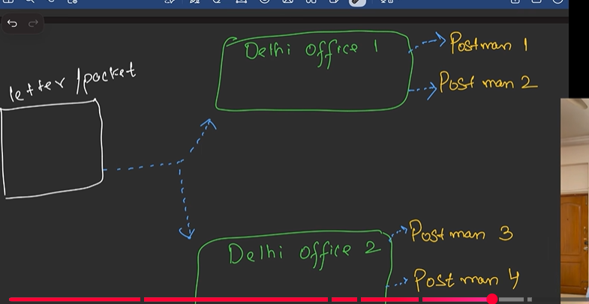

2. The Load Balancer (The Restaurant Host)
A Load Balancer is a device (or software) that sits in front of a group of servers and acts as a traffic director. It receives all incoming user requests and distributes them evenly across the servers so no single machine gets overwhelmed.
- The Analogy: Your restaurant got so popular that even your amazing multithreaded Chef can't keep up, so you hire three more Chefs (Servers). If 100 customers walk in and all shout their orders at Chef #1, Chef #1 will crash, while the other three stand around doing nothing.
- The Load Balancer Solution: You hire a Host (the Load Balancer) to stand at the front door. The Host takes the incoming customers and distributes them: "You go to Chef 1, you go to Chef 2, you go to Chef 3..." * In Tech Terms: When millions of people visit https://www.google.com/search?q=Google.com at the same time, they aren't all hitting one massive computer. They hit a Load Balancer, which quietly routes their packets to thousands of different servers running in the background.

Multithreading concept

1. The Anatomy: Processes vs. Threads
Before multithreading, every program ran as a single process.
- A Process is a heavy, isolated container. When the OS launches an application, it creates a process and allocates a dedicated block of memory for it. This memory includes the application's code, global data, and a "Heap" (where dynamic memory is stored). Processes are completely walled off from one another.
- A Thread is the actual "worker" executing the code inside that process. Every process starts with at least one thread (the main thread).
Multithreading is simply creating additional workers inside that same container.
Because these threads live inside the same process, they share the same memory space (the code, the data, and the Heap). However, to keep track of where they are in the code independently, each thread gets its own private mini-workspace:
- Program Counter: Keeps track of which line of code this specific thread is executing right now.
- Stack: Stores local variables and function calls specific to this thread.

2. How the CPU Executes Threads (Context Switching)
You might wonder how a CPU with only one core can run 10 threads at once. The truth is, it doesn't.
If you have a single-core CPU, it uses Concurrency. The CPU gives Thread A a tiny slice of time (a few milliseconds) to execute. Then, it pauses Thread A, saves its exact state, loads the state for Thread B, and executes Thread B for a few milliseconds. This rapid swapping is called Context Switching. It happens so incredibly fast that it creates the illusion that all threads are running simultaneously.
If you have a multi-core CPU, the OS can use true Parallelism, assigning Thread A to Core 1 and Thread B to Core 2, allowing them to execute code at the exact same physical millisecond.

3. The Danger Zone: Shared Memory and Race Conditions
Because threads share the same Heap memory, they are incredibly efficient—they don't need to pass messages back and forth like separate processes do; they just read and write to the same variables.
But this is also the biggest headache in software architecture.
If Thread A and Thread B both try to read, modify, and save the same variable at the exact same time, they will overwrite each other. This is called a Race Condition, and it causes unpredictable bugs that are notoriously difficult to track down.
To fix this, engineers use Synchronization tools, most commonly Mutexes (Mutual Exclusions) or Locks. When Thread A needs to update a shared variable, it "locks" that piece of memory. If Thread B tries to access it, Thread B is forced to wait until Thread A finishes and removes the lock.

FOR CONCEPT:
es, that is generally correct. CPU cores are physical processing units used for multitasking and multithreading, and in most scenarios, more cores allow for more simultaneous multithreading (parallelism).
TikTok +2
Here is a breakdown of how cores and threads work together:
1. Cores vs. Threads: The Factory Analogy
- Cores (The Workers): A core is a physical, independent processing unit within the CPU. Think of it as a worker in a factory. A 4-core processor has 4 workers.
- Threads (The Tasks/Jobs): A thread is a sequence of instructions (a task) that a core executes.
- Multithreading (The Setup): Modern CPUs often feature Simultaneous Multi-Threading (SMT), known as Hyper-Threading by Intel. This allows a single physical core to act like two "logical" cores, enabling it to manage two threads at once, maximizing efficiency.
2. How More Cores Affect Performance
- True Parallelism: If you have 4 cores, your CPU can process 4 independent tasks at the exact same time. If you have 8 cores, you can do 8 tasks simultaneously.
- Increased Throughput: More cores allow for better handling of heavy, parallelizable workloads like video editing, 3D rendering, or running multiple applications at once.
- Reduced Waiting: When a program has more threads to work with, it can split a job into smaller pieces, completing the task faster

PROJECT FLOW:

The Big Picture
You have a .pcap file
(recorded network traffic)
↓
DPI Engine reads it packet by packet
↓
For each packet:
- Parse headers
- Track the connection
- Inspect payload
- Decide: block or forward
↓
Write allowed packets to output.pcap
Show final report

What is a PCAP File?
Think of it like a video recording of all packets that traveled on your network. Wireshark records this.
packet_1: [raw bytes]
packet_2: [raw bytes]
packet_3: [raw bytes]
...
Each packet is just a sequence of bytes. Your job is to make sense of them.

Step 1: Reading the PCAP File
The program opens the file and reads packets one by one.
Each packet looks like this in raw bytes:
[Ethernet Header - 14 bytes]
[IP Header - 20 bytes]
[TCP Header - 20 bytes]
[Payload - variable]
Like a Russian nesting doll — headers inside headers.

Step 2: Parsing the Headers
The parser unwraps each layer and extracts useful information.
From Ethernet header:
Source MAC: 00:11:22:33:44:55
Destination MAC: aa:bb:cc:dd:ee:ff
From IP header:
Source IP: 192.168.1.100
Destination IP: 142.250.185.206
Protocol: TCP
From TCP header:
Source Port: 54321
Destination Port: 443 ← HTTPS!
Now we have the Five Tuple:
src_ip: 192.168.1.100
dst_ip: 142.250.185.206
src_port: 54321
dst_port: 443
protocol: TCP
This five tuple is like a unique ID for one conversation between your laptop and a server.

Step 3: Flow Tracking
The engine maintains a table in memory:
Five Tuple → Flow Info
─────────────────────────────────────────────────
192.168.1.100:54321 → YT:443/TCP → { sni: "", app: UNKNOWN, blocked: false }
192.168.1.100:54444 → FB:443/TCP → { sni: "", app: UNKNOWN, blocked: false }
192.168.1.100:55000 → G:443/TCP → { sni: "", app: UNKNOWN, blocked: false }
Every packet with the same five tuple belongs to the same connection and shares the same flow entry.
This is important because:
- Packet 1 of a connection won't have SNI yet
- Packet 3 might reveal the SNI
- After that, ALL packets of that connection get blocked

Step 4: SNI Extraction (The Heart of DPI)
This only happens on port 443 (HTTPS) traffic.
When your browser connects to YouTube, the very first message it sends looks like this:
TLS Client Hello
├── Version: TLS 1.2
├── Random bytes
├── Cipher suites (encryption methods browser supports)
└── Extensions:
└── SNI Extension:
└── "www.youtube.com" ← THIS IS VISIBLE IN PLAIN TEXT!
Even though everything after this is encrypted, this first message reveals the domain name.
The extractor reads the raw bytes and navigates to find it:
Byte 0: 0x16 → confirms it's TLS
Byte 5: 0x01 → confirms it's Client Hello
...skip session id...
...skip cipher suites...
...reach extensions...
...find extension type 0x0000 (SNI extension)...
...read the hostname string...
→ "www.youtube.com"

Step 5: Classifying the App
Once we have the SNI, we map it to an app:
"www.youtube.com" → YOUTUBE
"www.facebook.com" → FACEBOOK
"www.google.com" → GOOGLE
"github.com" → GITHUB
anything else → UNKNOWN
Now the flow table gets updated:
192.168.1.100:54321 → YT:443/TCP → { sni: "youtube.com", app: YOUTUBE, blocked: false }

Step 6: Checking Blocking Rules
Three types of rules are checked:
Rule 1 - Block by IP:
Is source IP 192.168.1.50? → DROP

Rule 2 - Block by App:
Is app YOUTUBE? → DROP

Rule 3 - Block by Domain:
Does SNI contain "tiktok"? → DROP

None matched? → FORWARD
If any rule matches, the flow is marked as blocked:
192.168.1.100:54321 → YT:443/TCP → { sni: "youtube.com", app: YOUTUBE, blocked: TRUE }

Step 7: Forward or Drop
if flow.blocked == true:
dropped_count++
don't write this packet to output

if flow.blocked == false:
forwarded_count++
write this packet to output.pcap
Simple as that.

Full Timeline of One YouTube Connection
Let me show you exactly what happens packet by packet:
Packet 1 → SYN (connection request)
Flow created, app=UNKNOWN, blocked=false
→ FORWARD (we don't know it's YouTube yet)

Packet 2 → SYN-ACK (server responds)
Same flow, still UNKNOWN
→ FORWARD

Packet 3 → ACK (connection established)
Same flow, still UNKNOWN
→ FORWARD

Packet 4 → TLS Client Hello
SNI found: "www.youtube.com"
App = YOUTUBE
Rule matched: YOUTUBE is blocked!
flow.blocked = TRUE
→ DROP this packet

Packet 5 → Data packet
Check flow → blocked = TRUE
→ DROP (no inspection needed)

Packet 6 → Data packet
Check flow → blocked = TRUE
→ DROP

...all remaining packets of this connection → DROP
Notice — packets 1, 2, 3 still get forwarded. That's unavoidable because we don't know it's YouTube until packet 4. In real-time blocking this causes a slight delay but the connection ultimately fails.

The Final Report
After processing every packet in the file:
Total Packets: 77
Forwarded: 69
Dropped: 8

Application Breakdown:
HTTPS → 39 packets (50%)
UNKNOWN → 16 packets (20%)
YOUTUBE → 4 packets (5%) [BLOCKED]
FACEBOOK → 3 packets (3%)

Detected Domains:
www.youtube.com → YOUTUBE (blocked)
www.facebook.com → FACEBOOK
www.google.com → GOOGLE

The Complete Flow in One Diagram
PCAP File
│
▼
┌─────────────┐
│ PCAP Reader │ → reads raw bytes packet by packet
└──────┬──────┘
│
▼
┌──────────────────┐
│ Packet Parser │ → unwraps Ethernet, IP, TCP headers
└──────┬───────────┘
│
▼
┌──────────────────┐
│ Flow Tracker │ → finds or creates flow using 5-tuple
└──────┬───────────┘
│
▼
┌──────────────────┐
│ SNI Extractor │ → reads TLS Client Hello, finds domain
└──────┬───────────┘
│
▼
┌──────────────────┐
│ App Classifier │ → youtube? facebook? google?
└──────┬───────────┘
│
▼
┌──────────────────┐
│ Rule Checker │ → should this be blocked?
└──────┬───────────┘
│
┌──┴──┐
│ │
DROP FORWARD
│ │
│ Output
│ PCAP File
│
dropped
counter

That's the complete flow. Every single packet goes through this pipeline.

More details:
PCAP = Packet Capture file. Just a binary file storing recorded network packets with timestamps.

Where it comes from:
Yes, Wireshark records it. You open Wireshark, click start, use your laptop normally (browse YouTube, Facebook etc), click stop → it saves everything as a .pcap file.
That file is saved once. It's just a snapshot — like a photo. Your DPI engine reads that saved file, it doesn't connect to Wireshark live.

"Travel on your network" means your actual PC.
When you open Chrome and visit YouTube, your laptop is literally sending and receiving packets through your WiFi/ethernet. Wireshark sits and watches all of that and records it.

Simple timeline:
Day 1: Open Wireshark → browse YouTube/Facebook → stop → saved as test.pcap
Day 2: Run DPI engine on test.pcap → it analyzes that recording
The DPI engine never touches live traffic. It just reads the saved file like reading a book.

